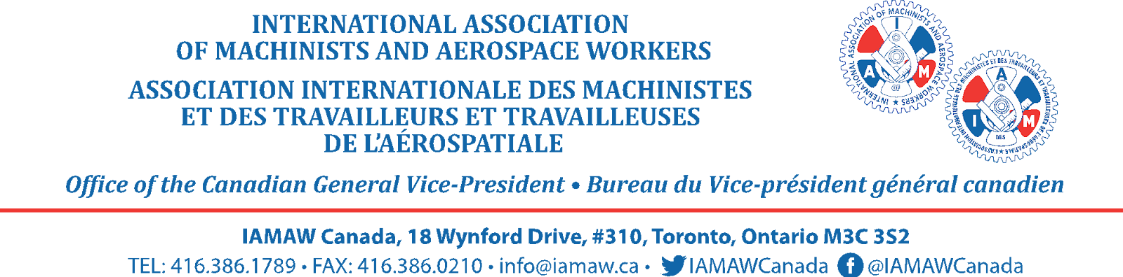

**Stay United as We Prepare for Negotiations with Air Canada**

Dear IAM Member,

As we approach an important negotiation period with Air Canada, I’m reaching out to stress the critical importance of standing united under the IAM banner. Our strength as IAM members comes from our solidarity, collective voice, and shared commitment to supporting one another.

After hearing from our proud members, and to preserve the good and welfare of the membership, we are looking at changes in District 140 to better represent our members.

At this time, some other unions may be encouraging IAM members to sign membership cards with them, but I urge you not to do so. Now more than ever, our solidarity is our strength, and any division could weaken our collective bargaining power.

Our upcoming negotiations with Air Canada are a crucial opportunity to secure industry leading wages, benefits, and working conditions for every one of our members. The IAM has represented airline employees for decades, and we’ve built a strong foundation of support and experience in fighting for industry leading working conditions. Dividing our membership now could disrupt our momentum and undermine the leverage we need to negotiate effectively.

If there are specific issues you want addressed in negotiations, bargaining surveys will be out over the coming months. Your input is essential, and we are here to ensure our collective bargaining team has the tools to deliver a world class agreement.

Let’s remain focused and unified so we can face these negotiations with the full strength of our membership behind us.

Thank you for standing together with us as we work to secure an industry leading contract for all IAM members working at Air Canada.

In Solidarity,

**David Chartrand**

IAM Canadian General Vice-President

30 October, 2024